Disclaimer:

The following sample notes are provided by Miller Environmental to help design engineers specify the specific product. It is the responsibility of the design engineer to ensure that product specifications and notes are complete and consistent with specific projects.

By using all or part of these specifications and notes the user agrees to hold Miller Environmental Corp. harmless from any liabilities or damages that may occur from use of these specifications and notes.

SAMPLE INSTRUCTIONS FOR HOLDING TANK INSTALLATION

- The holding tank shall be lined with the specified liner on the inside and or the outside of the tank as shown in the accompanying graphics (as shown below) with double lining on the tank bottom, to provide additional protection to the liner against tank failure.

- The liner will be a polyvinyl chloride (PVC) flexible membrane liner 30 mil thick or as otherwise specified by the design engineers and will be field installed in the prersence of the design engineer and a representative of Miller Environmental Corp.

- The tank, with liners, shall be installed on a level and compacted bed of clean granular sand with 40 mil (lldpe) model #mbe40m material specified by the design engineer not less than ¼-inch thick. This material shall be placed between the external tank liner and the compacted bed of sand.

if you are specifing the outside lid and tank liners, the liners will be field connected using Miller Environmental Tape on both the inside and outside seams, connecting the lid liner to the tank liner. when specifing an inside liner, the liner will be secured to the tank using strapping and concrete anchors provided by Miller Environmental Corp.

- The liner will be fabricated with boots fastned by stainless steel hose clamps to provide a water-tight seal around the inlet and or outlet vent pipes, boots should also be used on any other pipe penertrations.

- A plaque or sign shall be installed on or in the area of the tank access manway cover instructing waste haulers of specific techniques to avoid damaging the liner during routine pumping.

The following is example plaque language; final language shall be approved by the design engineer and local approving authority:

This tank is lined with a flexible Membrane material. To avoid punctureing or damaging the liner, do not create suction against the liner or use sharp objects within the tank.

Miller Environmental corp. (508)378.3800

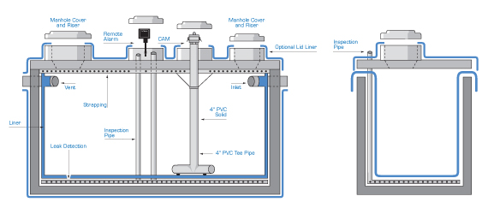

as shown above top left: an outside lid liner and outside tank liner is 360 degrees of coverage for use in potential high ground water applications. the inside liner is to protect the concrete of deteriation from any harmful contents

as shown top right drawing: this is an inside liner for secondary containment with leak detection and inspection system. you can have visuial and or alarm inspection ports. also shown in this drawing is an optional lid liner for protection of surface run off.
all pipe penatrations and manhole risers should have boots
when specifing non hazardous systems please use model number #mslcs30pvc

for hazardous containment systems please use model number #mslcs30x5

SAMPLE INSTRUCTIONS FOR BREAKOUT BARRIER INSTALLATION
model #mbe40m

- Provide 40mil. polyethylene liner as available from Miller Environmental Corp., East Bridgewater, MA (508.378.3800).

- Install liner around the entire soil absorption system as shown ____-feet from edge of the system and vertically from Elev.. ____ down to Elev. ____ .

- Cover with minimum ____-inches of general fill containg no stones greater than 2-inches and ____-inches of loam prior to seeding or landscaping.

